

**IT0010 - Computational Thinking and 21st Century Skills**

Self-Guided Activity Report

MOHAMED SAKITH MN.

Faculty of Computing.

IT23207172

Content

Activity1 Identifying your Self-concept

Activity2 Creating your Resume

Activity3 Learning how to be safe on the internet

Activity4 Academic information seeking

Activity5 Academic writing

Activity6 Developing a search strategy

Activity7 Data visualization

Activity 8 How emerging technology impacts day to day life

Activity 9 Exploring Emerging Technologies for Lifelong Learning and

Success

**Activity 1 Identifying your Self-concept**

Completed date – [26.05.2023]

Hi, I am Sakith. I always feel-good while being silent but, I like to spend my leisure time with my peers and friends those who encourage, support and help me in every situation. Although some of my peers and surrounding human beings thinks that I am an introvert. I really don’t know why they are thinking like this. But I always think good about others and focus only on their positive and never sort out their negatives.

I always think this is one of my best qualities. Because of this quality I got most valuable relationship with them. An important lesson I got to known was my hidden talents. I also get to know about how to react and behave with others. Also, I had beautiful memories with them. Talking Silly things and unbreakable secrets make my mind free. I feel good at this because making conversation free with each other without any limits can lead a good relationship. Being good with others also can be helpful to lead interpersonal skills.

Activity2 Creating your Resume

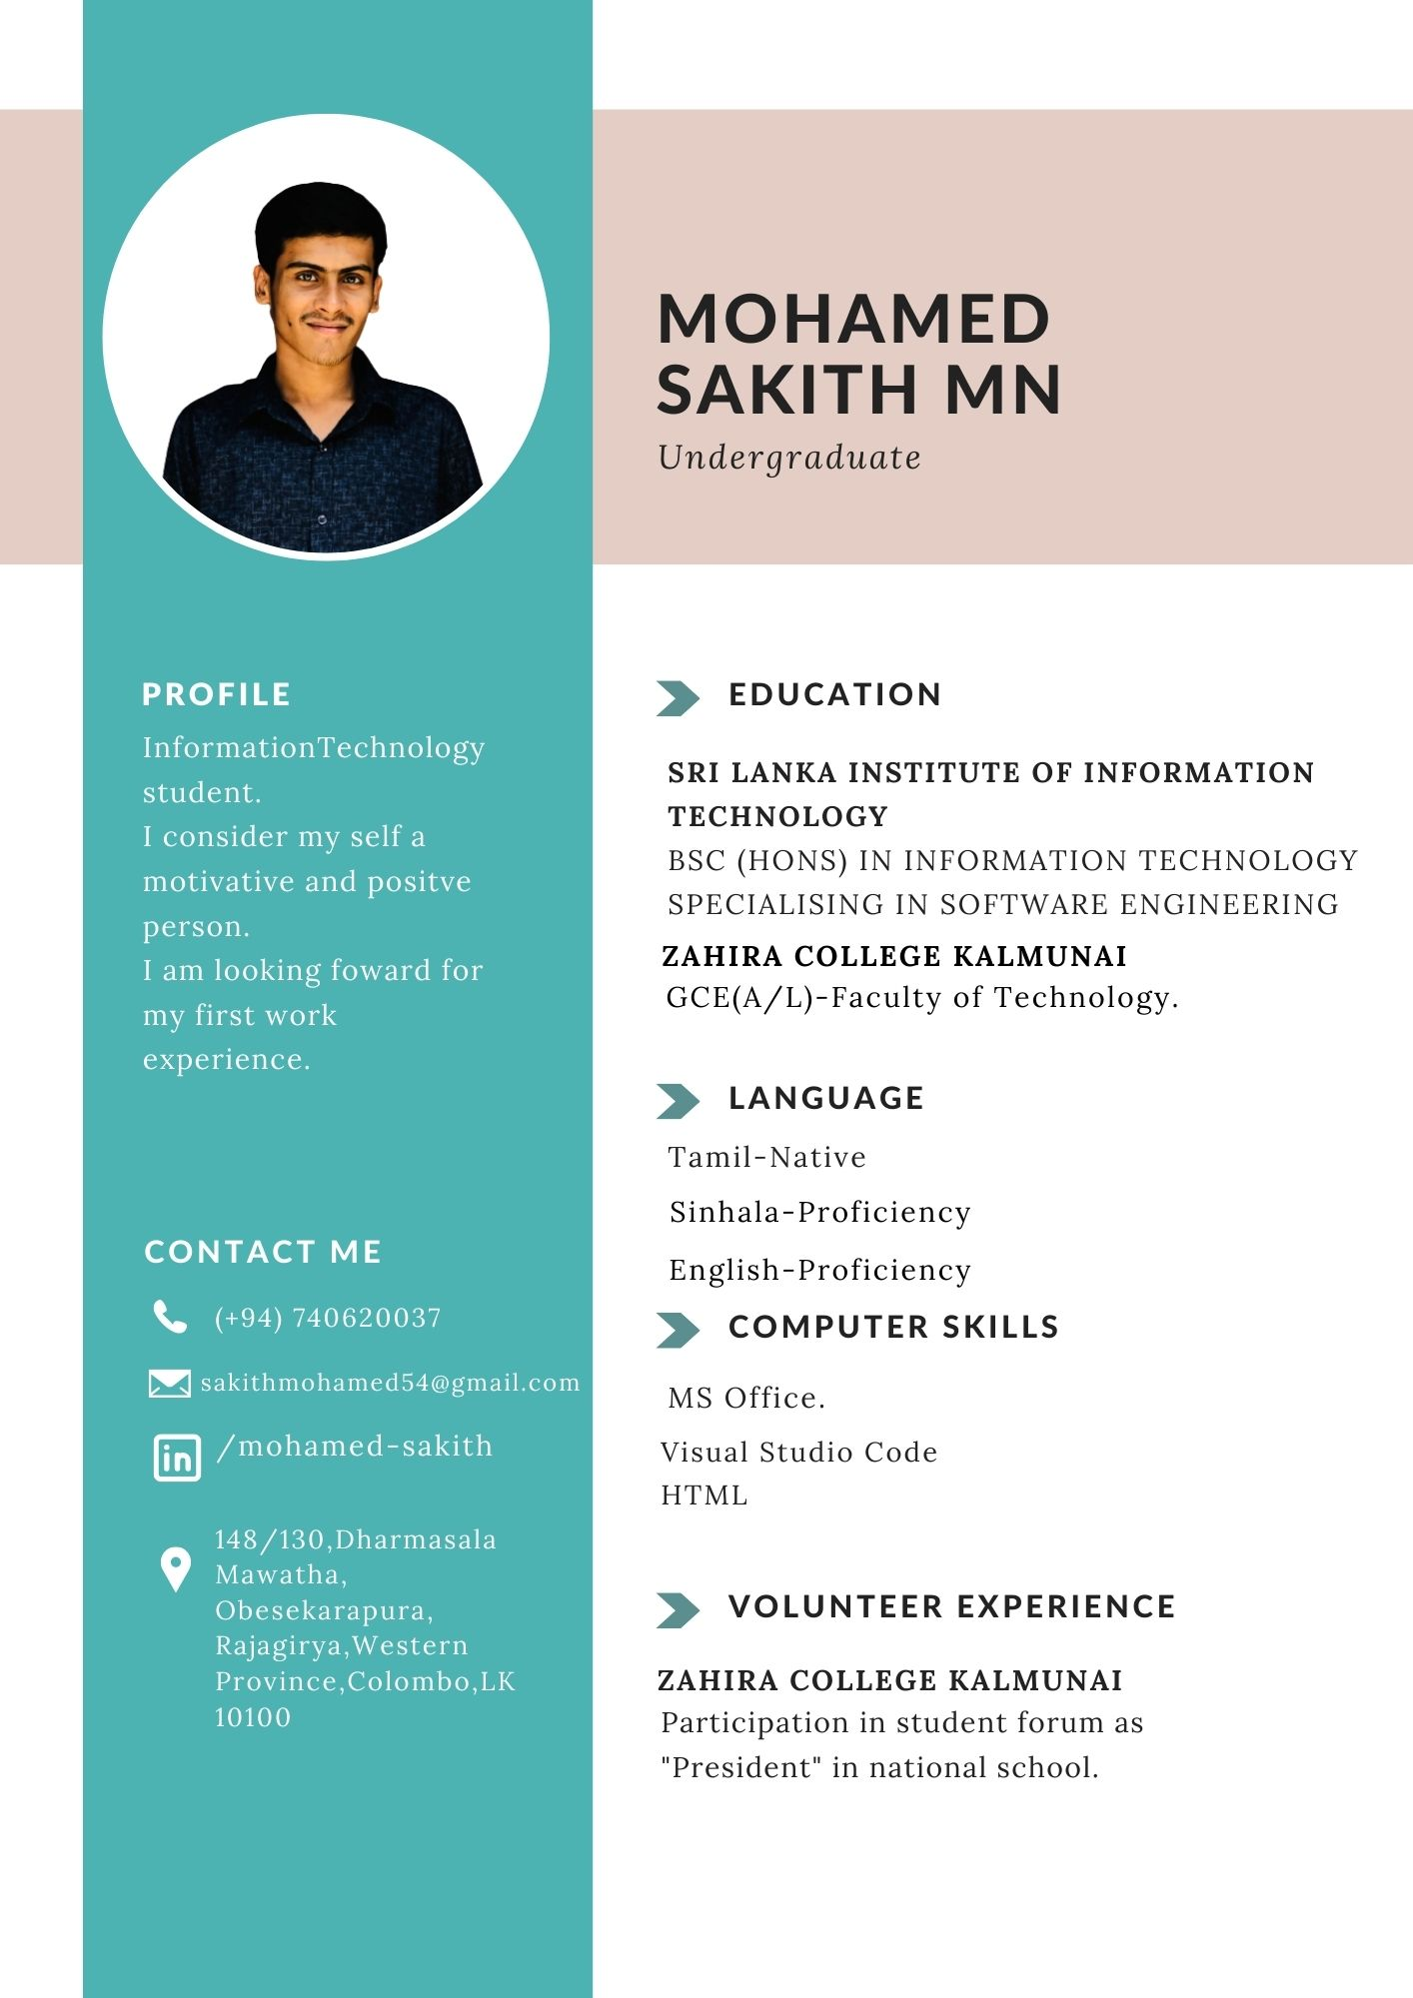Completed date – [26.05.2023]

Activity3 Learning how to be safe on the internet.

Completed date- [31.05.2023]

Now a days in human life the computer has bought a lot of changes in the way of doing simple tasks and made human life easier. It’s use in many fields like business, e-commerce and communication. If we talk about the major advantage of computers, it is the Internet. The Internet is the human’s successful invention. For humans it has made to do a lot of things quickly and effortlessly. For example, people can contact and communicate with anyone in the world, and, sitting at home, they can purchase, and they can also earn money. but just it has made easier, also it comes with the security issue that your data can be easily misused, everything you have is digital and can be misuse if security is compromised, but also there are ways through we can protect our self from these kinds of flaws.

There are also laws which protect this kind of computer issues. Prevention of Electronic Crimes Act, 2016 which deals with the computer improper use cases. It is illegal to copy someone’s data without the person’s approval whether it’s in form of literature work, source code, pictures, or an application. When a person tries to steal your data is liable for criminal charges. As this is improper use of network technology and computer it doesn’t just break the Copyright law as well as Prevention of Electronic Crimes Act, because when the intention of a person was to steal by copying someone’s private data by using the Internet or through an external device then it comes under the copyright law. The Internet is the best source for gathering different types of data and has a lot of benefits, but having all these facilities it also has drawbacks. As the Internet has useful things it also has some bad things like vulgarity or obscenity type of material, which is accessible through the Internet, these materials are being stored in the electronic form, and can be access able through devices like smart phones, tablets, and computers. So, adult children can easily access. These obscene materials have high risk damaging the future of young generation, but the law says it is a crime to produce and distribute vulgar material that is not good for the youth who are below age of 18.

We all know that there are many services and facilities on the Internet which help users to communicate with the world by using services like social media, applications, emails and more. Email is a service that facilitate user but also there are many cases of fraud by fake identity where a person pretends to be someone professional but at the end user is deceived in online harassment the victim gets frightened by the person and putting him/her in terror by giving threats that will misuse personal details of him/her such that he or she gets mentally stressed and try to self-harm.

There are many laws which provides protection to every user of the Internet from criminals who uses network to harm the users, also the users should take some steps to make entities that instruct the organizations who enforce the law, that how to inquiry those crimes which is related to the Internet and deal in effective way.

Activity4 Academic Information Seeking

Completed date- [31.05.2023]

Digital tools **streamline your research process, help you stay organized, and provide you with easy access to the information you need.** Before any digital tools for researchers were introduced, academics had to rely on old-school manual methods that were typically time-consuming, labor-intensive, and also limited in scope. For instance, you had to subscribe to journals or physically visit libraries and spend hours searching and sifting through tomes before finding the most relevant information. And once that was done, the process of organizing, storing, and referencing data was another challenge you had to overcome.

In contrast, online tools for researchers offer a wealth of information and resources at your fingertips today. With the option to search and access vast amounts of knowledge with a few clicks, researchers are able to boost their efficiency and effectiveness at work. With the option to search and access vast amounts of knowledge with a few clicks, researchers are able to boost their efficiency and effectiveness at work. And it’s not just limited to online tools for researchers that allow you to easily store, organize, and manage information, there are a number of tools that can help you hone your writing, check for plagiarism, find the right journal, collaborate with other researchers, and share your knowledge, ideas, and resources. The rapid development of digital tools for researchers have revolutionized the way researchers work, making way for faster innovation and more groundbreaking research.

The range of things academic writing tools can do for you is astonishing – language editing, abstract writing, plagiarism checking and so much more! While there are a number of online tools for researchers that can help improve your academic writing, here are our top choices in this category that you should know about. iThenticate by Turnitin is an online plagiarism checker designed specifically for researchers and academics to review their manuscripts prior to journal submission and publication. One of the well-known tools for researchers, Scholarcy is an innovative AI engine that helps you analyze different sections of an article, filter out the noise, and deliver a precise structured summary of the research.

There are various ethical issues that arise in access and use of information such as privacy of information, ownership of the data, the security of the information. Some of the major ethical issues faced related to access and use of information are Personal piracy, cyber-crime, **identity theft, identity theft, click fraud, advance fee fraud and hacking** with great power comes great responsibility. Information systems bring new opportunities and advantages to how we related to access and use of information but they also introduce issues that can negatively affect society.

Privacy

Person Access Right

Activity5 Academic Writing

Completed date- [08.06.2023]

This research publication or paper deals with formulating a suitable title and an appropriate abstract for an original research paper. The “title” and the “abstract” are the “initial impressions” of a research publication, and hence they need to be drafted correctly, accurately, carefully, and meticulously. Most readers read only the title and the abstract of a research paper and very few will go on to read the full paper. The title and the abstract are the most important parts of a research paper and should be pleasant to read. The “title” should be descriptive, direct, accurate, appropriate, interesting, concise, precise, unique, and should not be misleading. The abstracts can be structured or unstructured. They can also be classified as descriptive or informative abstracts. The abstract should be consistent with the main text of the paper, especially after a revision is made to the paper and should include the key message prominently.

Referencing allows you to acknowledge the contribution of other writers and researchers in your work. Any university assignments that draw on the ideas, words or research of other writers must contain citations. Referencing is also a way to give credit to the writers from whom you have borrowed words and ideas. By citing the work of a particular scholar, you acknowledge and respect the intellectual property rights of that researcher. As a student or academic, you can draw on any of the millions of ideas, insights and arguments published by other writers, many of whom have spent years researching and writing. All you need to do is acknowledge their contribution to your assignment. **Digital tools save you time, ensures consistent referencing, allows you to keep your research organized and enhances your**[digital literacy](http://www.jisc.ac.uk/full-guide/developing-digital-literacies)**skills.** when undertaking a longer project or dissertation, you may wish to consider how to manage all of the research references that you collect during your work. This can be a challenge, especially if you have many references so you may wish to use reference management to assist you with this. Examples of tools are given below but you may wish to find out what is used in your department or by your supervisors/ colleagues. They are “RefWorks, End Note, Mendely, Zotero, JabRef, Papers, Docear and Paper Pile”.

A conclusion is an important part of the paper; it provides closure for the reader while reminding the reader of the contents and importance of the paper. It accomplishes this by stepping back from the specifics in order to view the bigger picture of the document. In other words, it is reminding the reader of the main argument. For most course papers, it is usually one paragraph that simply and succinctly restates the main ideas and arguments, pulling everything together to help clarify the thesis of the paper. A conclusion does not introduce new ideas; instead, it should clarify the intent and importance of the paper.

Activity6-Developing a search strategy

Completed date- [08.06.2023]

Developing a search strategy is an iterative process— that is, it involves continual assessment and refinement. As keywords or key terms are used in a search, their usefulness will be determined by the search results. Consequently, searching for evidence is sometimes considered more of an art than a science. It’s therefore unlikely that two people, whether they are clinicians or librarians, will develop an identical search strategy or yield identical results from a search on the same review question. The search strategy combines the key concepts of your search question in order to retrieve accurate results. Your search strategy will account for all possible search terms, keywords and phrases, truncated and wildcard variations of search terms and subject headings (where applicable)

#### Search strategy, including the filters (such as language, date limits) and databases and other sources used. A hallmark of a systematic review is its reproducibility; another researcher should be able to review the same question and arrive at similar conclusions. Without a transparent reporting of the search strategy—one that allows readers to assess the quality of the search and its sources, and in turn, make a judgment on the likely credibility of the review. Start developing a search strategy by identifying the key words and concepts within your research question.  search strategy across multiple database platforms as part of the process of developing a search strategy, it is recommended that you keep a master list of search terms for each key concept. This will make it easier when it comes to translating your search strategy across multiple database platforms. Boolean operators are used to combine the different concepts in your topic to form a search strategy. The main operators used to connect your terms are **AND** and**OR**. **Use symbols to retrieve word variations, use quotes to keep word order when searching for phrases**

Activity7 Data visualization

Completed date- [11.06.2023]

Visualization is one of the most important components for displaying massive amounts of data in a way that is easily accessible. Also, Data visualization refers to any graphic that examines or communicates data in any discipline. Data visualization is concerned with the design, development, and application of computer-generated graphical representation of the data. It is easier for the brain to comprehend an image versus words or numbers (Cukier, 2010), making effective graphics is an especially important part of academic literature. Data visualization is concerned with the design, development, and application of computer-generated graphical representation of the data.

The objective of any graphic in the context of presentations is to effectively convey information. It provides effective data representation of data originating from different sources. This enables decision makers to see analytics in visual form and makes it easy for them to make sense of the data. It helps them discover patterns, comprehend information, and form an opinion.

Visualization is the use of computer-supported, visual representation of data. Unlike static data visualization, interactive data visualization allows users to specify the format used in displaying data.

• Line graph: This shows the relationship between items. It can be used to compare changes over a period of time.

• Bar chart: This is used to compare quantities of different categories.

• Scatter plot: This is a two-dimensional plot showing variation of two items.

• Pie chart: This is used to compare the parts of a whole.

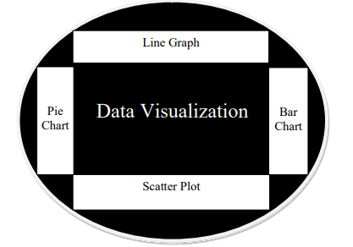

Activity8- How emerging technology impacts day to day life

Completed date- [12.06.2023]

Technology is playing a main role in every aspect of daily life now. Technology has certainly changed the way we live. It has impacted different facets of life and redefined living. Undoubtedly, a huge change to how we live our lives is pretty incredible and I couldn’t imagine not having it. Several manual tasks can be automated, thanks to technology. Also, many complex and critical processes can be carried out with ease and greater efficiency with the help of modern technology. However, that potent role in our daily rhythms, the ability to do so much at almost any time, can lead to feelings of tech not always aligning with the complete picture of our needs.

We can connect with family remotely with ease or work from home and collaborate and communicate with colleagues in real-time. Several manual tasks can be automated, thanks to technology. Also, many complex and critical processes can be carried out with ease and greater efficiency with the help of modern technology. We have unparalleled access to information and can connect with other people that share our interests. However, that potent role in our daily rhythms, the ability to do so much at almost any time, can lead to feelings of tech not always aligning with the complete picture of our needs. Technological advances in communication have become endless. Technology is of great importance in terms of facilitating communication between people, as it has contributed effectively to making the big world look like a small village. Technology provides the possibility to spread information and various.

Technology has helped doctors answer all patient queries faster. There are various technological innovations in the health sector, such as the invention of certain drugs, the development of information technology, biotechnology, and development processes. Technology constantly strives to contribute to the development of instruments and equipment used in the medical field and preserve the healthy lives of people and raise their standard of care.  Information technology and its applications in the business world have facilitated the use of computers and allowed the use of the Web, thus making work more flexible. The role of technology in the field of education is fourfold: it is included as a part of the curriculum, as an instructional delivery system, as a means of aiding instructions and also as a tool to enhance the entire learning process. Technology has a positive impact on education and at the same time may also pose negative effects. It is thus time for every country to introduce a more technologically equipped education sector in the future.

Activity9- Exploring Emerging Technologies for Lifelong Learning and Success

Completed date- [18.06.2023]

Emerging technologies introduces various technological tools and resources, which are explored through hands-on Discovery Learning Exercises in the MOOC modules. The MOOC is supported by the complementary emerging technology WIKI, a socially curated collection of technology tools and resources that is also available as a stand-alone open educational resource. A peer-review activity is part of the final module, during which participants assess the ePortfolio they developed to highlight the artifacts they created in the first four modules.

MOOCs are online courses that a student accesses through the internet. which may include the following filmed or recorded video lectures, readings, problem sets, online quizzes and examinations, interactive learning modules and interaction with other students via forums. Yet using ICT to increase access to education and training has also formed a substantial part of New Labor’s technological agenda. At the school and

college level this ambition has been crystallized in the £1.8billion National Grid

for Learning (NGfL), an umbrella term for the government’s various

programmers concerned with integrating ICT into schools and further education

colleges across England, Wales, Scotland and Northern Ireland. In spanning a

diverse set of individual programmers, the NGfL is strongly based around

increasing young people’s use of ICT whilst at school. In terms of infrastructure,

the initial implementation of the NGfL has concentrated on increasing the

quantity and quality of computer hardware in schools as well as laying the

foundations for a ‘networked learning community’ of schools, colleges, libraries. The new technology-based lifelong learning discourse is by no means dominated by overt economically-determinism. Much of the present discourse is driven by an overt technological determinism and technophillia; in other words, an easy and uncomplicated explanation of technological determinism where technology is the principal force that determines the nature of society. In particular, much of the government’s positioning of the technological ‘reconstruction’ of lifelong education has been firmly based around well-worn notions of the ‘information age’ and ‘information society’.

In reaching this somewhat gloomy conclusion we are not contending that technology is incapable of being used to refashion ‘lifelong learning’ into a truly moral activity that could have relevance and attraction to non-participants. Technology does have the potential to be a means through which popular perceptions of lifelong learning could be reconfigured in non-economic terms as well as economic terms and recognize that learning with no economic purpose is just as valuable and important as any other form of motivation.

REFERENCES

Activity 1- <https://www.coursesidekick.com/business/study-guides/buswriting/self-concept-and-dimensions-of-self>

Activity 2- <https://www.coursera.org/learn/how-to-write-a-resume>

Activity 3- <https://edubirdie.com/examples/essay-about-internet-safety/>

Activity 4-<https://smiling-swati20.medium.com/ethical-issues-that-may-arise-in-information-management-6abfa1b64fd4>

Activity5-[https://www.ncbi.nlm.nih.gov/pmc/articles/PMC6398294/#:~:text=The%20title%20and%20the%20abstract%20are%20the%20most%20important%20parts,and%20should%20not%20be%20misleading](https://www.ncbi.nlm.nih.gov/pmc/articles/PMC6398294/%23:~:text=The%20title%20and%20the%20abstract%20are%20the%20most%20important%20parts,and%20should%20not%20be%20misleading).

<https://www.student.unsw.edu.au/why-referencing-important>

<https://www.ref-n-write.com/blog/top-referencing-tools-and-reference-management-software-for-academic-writing/>

Activity6- <https://www.mq.edu.au/__data/assets/pdf_file/0011/788375/Aromataris-2014-Constructing-a-search-strategy-and-searching-for-evidence.pdf>

Activity7- <https://www.sciencedirect.com/science/article/abs/pii/S1364815210003270>

<https://www.researchgate.net/profile/Adebowale-Shadare/publication/311597028_DATA_VISUALIZATION/links/5851945608aef7d0309f20a7/DATA-VISUALIZATION.pdf>

Activity8[- https://www.scientificworldinfo.com/2019/11/importance-of-technology-in-our-daily-life.html](-%20%20%20%20%20https:/www.scientificworldinfo.com/2019/11/importance-of-technology-in-our-daily-life.html)



Activity9- [https://topkit.org/developing/tools-techniques-strategies/suny-emtechmooc/](https://topkit.org/developing/tools-techniques-strategies/suny-emtechmooc/%20%20%20)

[https://www.techtarget.com/whatis/definition/massively-open-online-course-MOOC#:~:text=A%20massive%20open%20online%20course,course%20or%20be%20less%20structured.](https://www.techtarget.com/whatis/definition/massively-open-online-course-MOOC%23:~:text=A%20massive%20open%20online%20course,course%20or%20be%20less%20structured.)

<https://www.tandfonline.com/doi/abs/10.1080/13596740300200141>

THANK

YOU.